|  |
| --- |
| South Africa Livelihood Zone Profile  59205 – Highveld Open Access Mixed Income (*ZAHMI*) |
| Zone Description |

The livelihood zone is characterised by variations in relief, climate and vegetation. It covers Fertile Areas of Groblersdal, Marble Hall and the livestock producing areas of Rust De Winter and KwaMhlanga. The undulating grassy plains of the Highveld give way to the lower-lying Bushveld areas and the mountainous terrain dissected by the Olifants River. Soils are fertile: they are heavy greyish and red alluvial duplex soils, well drained and falling in the Hutton form, ranging from a Shorrocks series to a Makhatini series (the clay contents range from 15 to 35%). Rainfall is seasonal, and is distributed mostly in the summer months between November and April, while the winters are generally cool and dry. The Loskop, Arabie, Rust de Winter and Mkhombo Dams are important reservoirs for water in the livelihood zone. The areas within the catchment of the Olifants River have abundant surface and ground water supplies for commercial irrigation, tourism, industrial and domestic uses.

Figure 1: Map of the livelihood zone

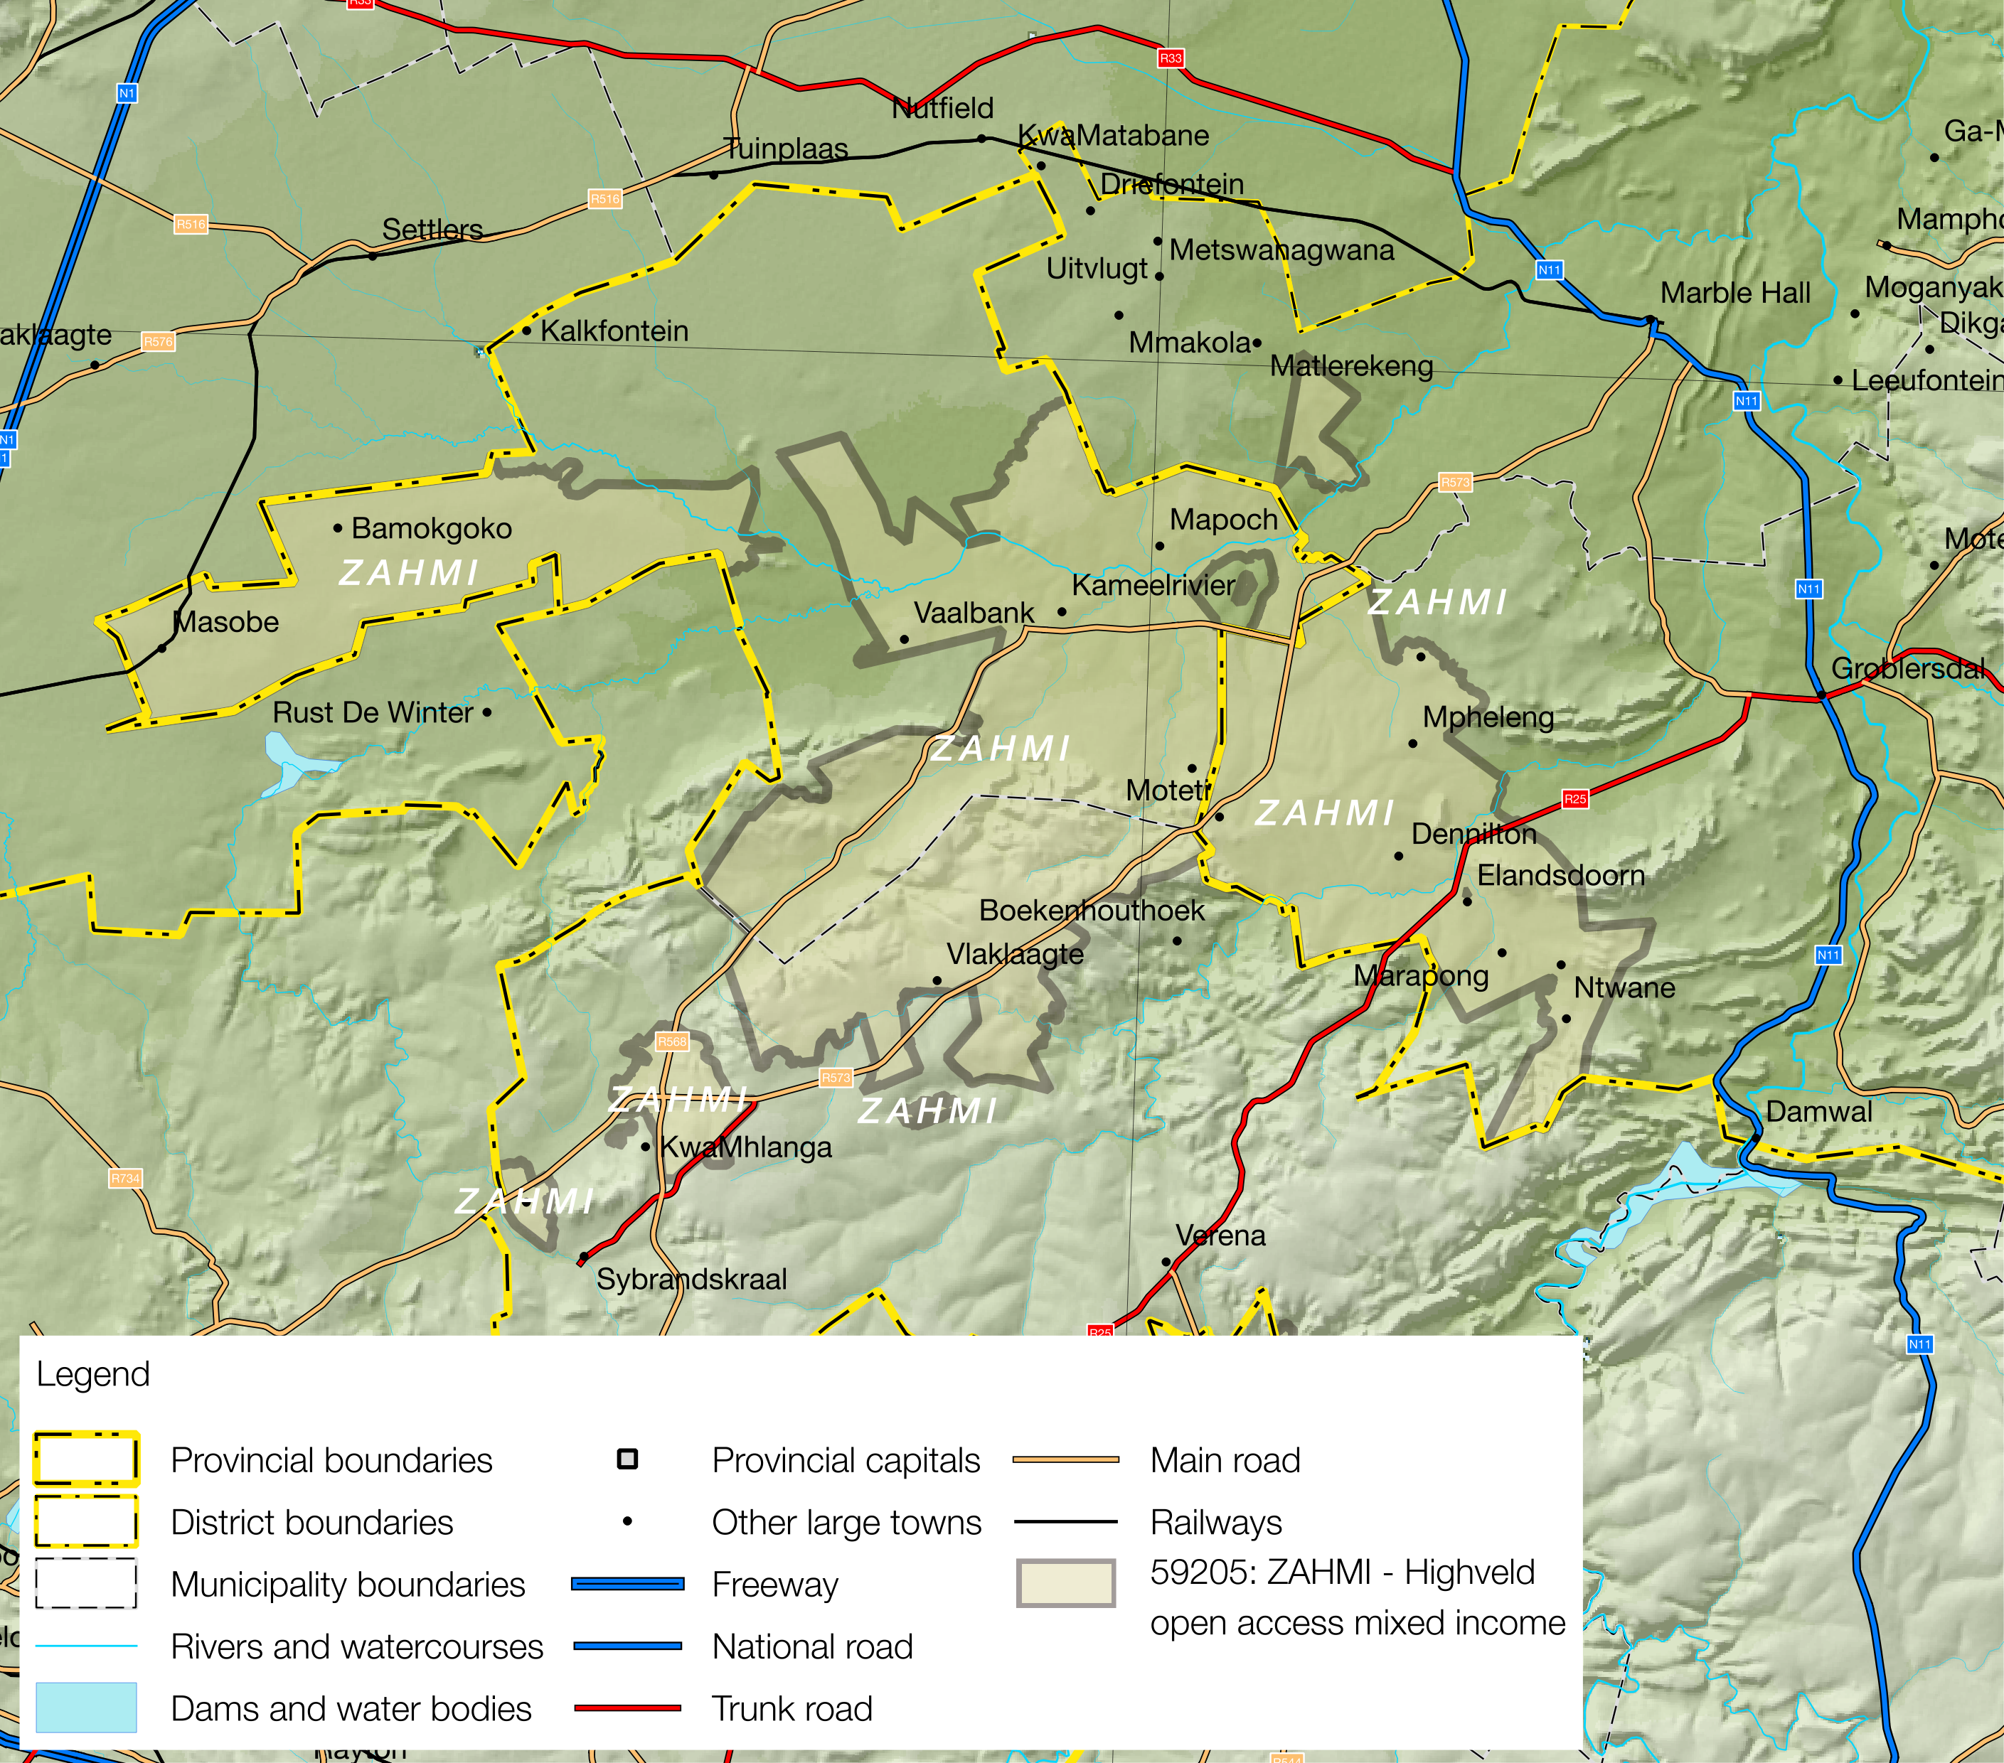

Projection: Albers Equal Area with Standard Parallels at 24.2 ªS and 32.8 ªS, Longitude of Centre at 25.1 ªE..

Sources of data: Open Street Map, Highways (<http://wiki.openstreetmap.org/wiki/Planet.osm>) for the road lines, Shuttle Radar Topography Mission (SRTM) 3 version 2.1 (<http://www2.jpl.nasa.gov/srtm/>) for the elevation and relief shading and Agricultural Geo-referenced Information System (AGIS) (<http://www.agis.agric.za/agisweb/agis.html>) for place names, boundaries and rivers.

Major roads such as N11, R568, R573 and R25 connect areas in the zone to commercial centres of Marble Hall, Siyabuswa, KwaMhlanga, Bronkhorstspruit, Groblersdal, eMalahleni and Middelburg. The livelihood zone is only 70-130 km away from Pretoria (via the Moloto Road)

Table 1 - 2016 Population breakdown of districts and municipalities covered by the livelihood zone, based on the 2011 Census and annual projections

|  |  |  |  |  |
| --- | --- | --- | --- | --- |
| **Province** | **District** | **Municipality** | **Pop. Est. in ZAHMI** | **% of Admin Level** |
| Limpopo | Greater Sekhukhune | Elias Motsoaledi | 86,273 | 31.65% |
| Ephraim Mogale | 4,244 | 4.39% |
| **Provincial Total** | | | **90,517** | **1.55%** |
| Mpumalanga | Nkangala | Dr J.S. Moroka | 168,180 | 60.56% |
| Thembisile | 218,009 | 63.12% |
| **Provincial Total** | | | **386,189** | **8.86%** |

Source: Statistics South Africa, Census 2011 small area population data and district population projections

Figure 2: Livelihood zone location

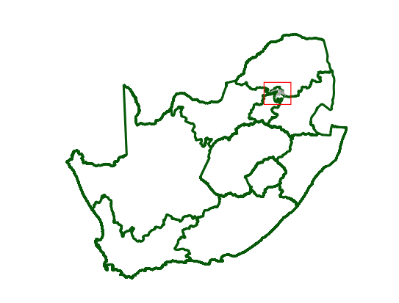

**Figure** is a map of the zone and  **Figure** shows the location.

The livelihood zone has been given an alphabetic code (or abbreviation) of 'ZAHMI' and a numeric code of 59205. These codes distinguish the zone both nationally and internationally, as well as allowing zone name changes and updates if desired (the code should always remain the same).

The zone spans four municipalities in two districts and two provinces. However, not all of each of the municipalities are included in the zone; substantial areas and populations from each municipality are excluded. The zone population is 90,517 in Limpopo, which is 1.55% of the provincial total, and 386,189 or 8.86% of the provincial total in Mpumalanga (extrapolated from the 2011 Census).  **Table** shows the breakdown for each municipality.

Figure 3: Gender and age breakdown of the zone population

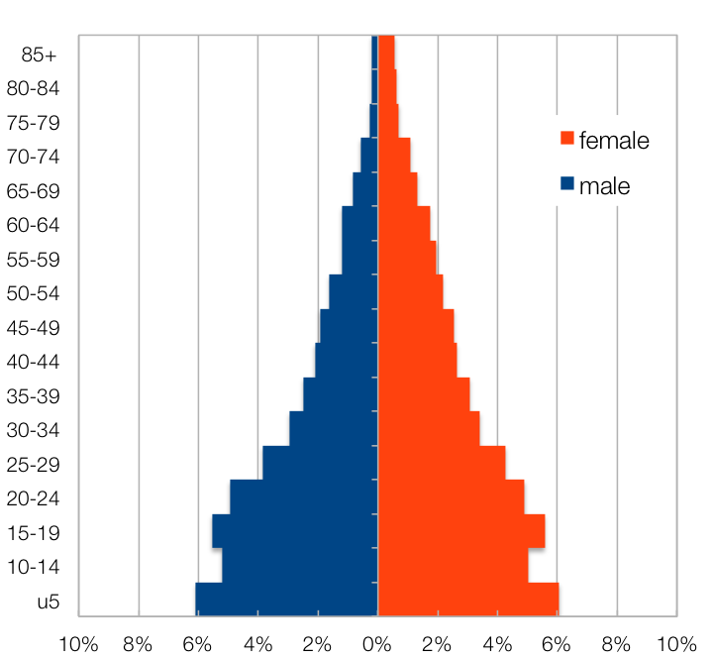

Source: Statistics South Africa, Census 2011 small areas and population database

The age and gender breakdown of the livelihood zone is given in  **Figure**. This pyramid does not display the usual low proportions of adult men in the livelihood zone that is found in many other zones. This is because, being in relatively close proximity to the cities of Gauteng, there is less migration of younger men.

|  |
| --- |
| Seasonal Calendar |

This zone is adjacent to the well-known extensive irrigated farming of the Loskop Valley. There are numerous lush crops such as wheat, cotton, sunflower as well as citrus play a very important role in the country’s economy. Groblersdal is South Africa’s second largest irrigation settlement. As you enter this area, you will spot the flood plains of cotton, tobacco, table grapes, citrus fruit, maize, wheat, vegetables, sunflower seeds, peanuts, peaches as well as Lucerne.

Figure 4: Seasonal calendar

.

|  |
| --- |
| Wealth Breakdown |

Wealth in this livelihood zone is determined primarily by three factors:

1. Primarily formal (salaried) employment, the result of education and good social connections;
2. Ownership of a business, such as a spaza shop or bakkie, taxi; and
3. Livestock, especially cattle.

Land ownership is similar for all households and land use is mostly residential, despite the good soils and rainfall that is available.

The wealthiest households, described as the ‘better-off’, are those with permanent work or a good business that earns around R18,000 per month, while those with lower incomes of around R5,000 to R12,000 per month are referred to as ‘middle’. Households that have lower-wage, casual or seasonal work depend for their cash income primarily on grants and are described as the 'poor' and 'very poor', they collectively make up 70% of the population.

Figure 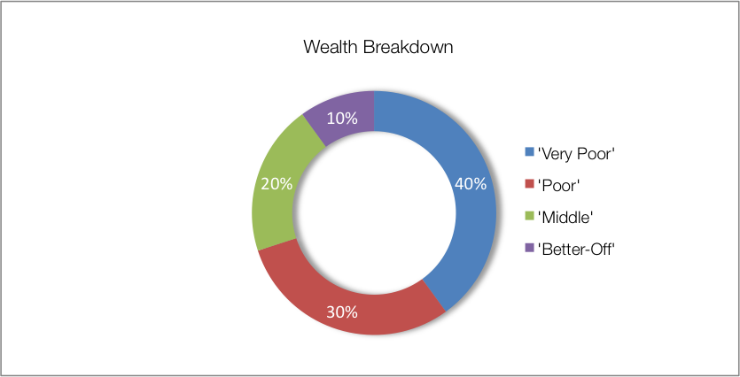5: Wealth breakdown in the lowveld open access irrigated cropping livelihood zone

|  |  |  |  |  |  |
| --- | --- | --- | --- | --- | --- |
| Category | Item | Wealth Group (typical value in brackets) | | | |
| 'Very poor' | 'Poor' | 'Middle' | 'Better off' |
| Hh Size |  | 6-9 (7) | 5-8 (6) | 5-6 (5) | 3-5 (4) |
| Land (Ha) | Owned | ½-5 (½) | ½-5 (½) | ½-5 (½) | ½-6 (½) |
| Cultivated | 0-0.2 (0) | 0-0.3 (0) | 0-1 (0) | 0-5 (0) |
| Livestock (head) | Cattle | 0 | 0-7 (3) | 6-10 (8) | 10-20 (15) |
| Goats | 4-5 (5) | 5-14 (6) | 10-15 (10) | 15-25 (20) |
| Income | Main source | Grants | Grants | Formal employ | Formal employ |
| Annual (R) | 44,800 | 61,500 | 133,200 | 211,700 |

Source: Survey output, 2015

Interview key informants in the villages tended to provide larger household sizes because they lumped smaller households or households with lone members into larger family units. This explains why the household sizes given in Figure are larger than those in the census. This grouping of households also reflects an element of family sharing, where social grants or wage incomes may be shared among two or three ‘actual households’.

|  |
| --- |
| Sources of Food |

This zone is well known for its rather extensive irrigation farming where numerous lush crops such as wheat, cotton, sunflower as well as citrus play a very important role in the country’s economy. Groblersdal is South Africa’s second largest irrigation settlement. As you enter this area, you will spot the floodplains of cotton, tobacco, table grapes, citrus fruit, maize, wheat, vegetables, sunflower seeds, peanuts, peaches as well as Lucerne.

Despite the crop farming, purchases still make up the largest portion of people's sources of food. Food purchases contribute above 75% of food sources for all households in the zone. The contribution to food energy from staple food purchase increases steadily from 58% for the 'very poor' to 86% for ‘better off’ households.

Figure 6: Sources of food (expressed as percentage of minimum average food energy needs) for each wealth group

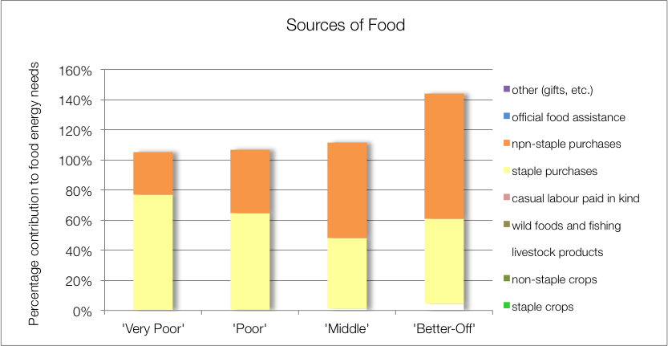

The contribution to food energy from non-staple food purchases increases from 25% of energy requirements for the 'poor' to 47% for the 'better off'. The average contribution to food energy for staple crops is 5% for all wealth groups. Food energy from consumption of livestock products such as milk and slaughtered livestock meat contributes less than 10% for all wealth groups.

The ‘poor’, 'middle' and 'better off' households also obtain food from their livestock products; this is from occasional slaughter for meat. There are challenges relating to lack of infrastructure and minimal herd management in the zone.

The 'poor', 'middle' and 'better off' households obtain food from their livestock; this is from occasional slaughter for meat and, for the 'middle' and 'better off', from cow's milk as well. Dairy production in this zone is not commensurate with herd sizes and livestock ownership. In general, a fraction of lactating cows (about one out of every three) are actually milked for consumption.

|  |
| --- |
| Sources of Cash Income |

Cash incomes vary considerably across wealth groups, with the 'better off' earning R211,700 per annum, more than four times as much as the 'very poor', who earn only R44,800 per annum.  **Figure** shows this distribution—it must be noted that the bars in the figure are not quartiles, they represent wealth groups and wealth groups are *not* distributed evenly (see Wealth Breakdown, above).

Figure 7: Sources of annual cash income by wealth group

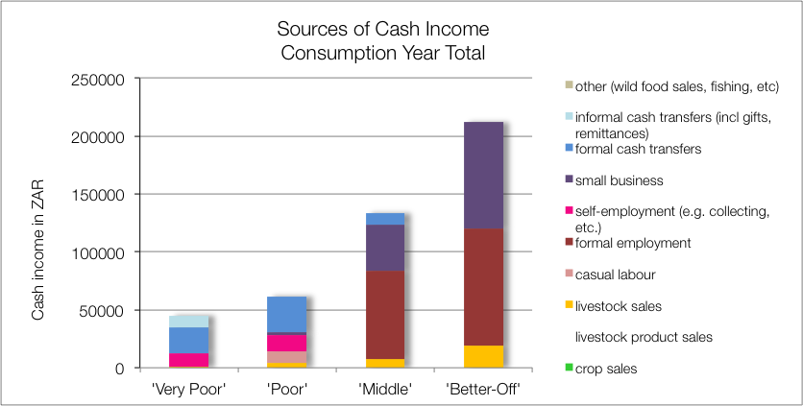

Income in this zone is sourced mostly through formal cash transfers, self-employment (firewood collection is popular), casual and seasonal agriculture labour, small business and formal employment. Livestock sales also bring in small amounts of extra income for the ‘poor’ ‘middle’ and ‘better-off’.

Figure 8: Sources of annual cash income as a percentage of total, by wealth group

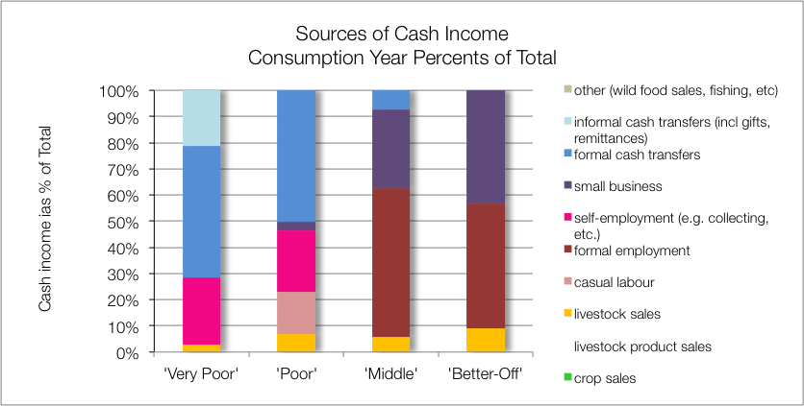

Households living on the eastern side of the zone benefit from casual or seasonal agricultural on the high production farms of the Loskop Valley, while households living on the western side are more likely to work temporarily in the cities of Gauteng or to receive remittances from relatives there.

Understanding how incomes add up is essential because it enables practitioners to link a hazard (such as a price change) to outcomes and it points to potential areas of intervention. By dividing the value of each source of cash income by the total, we can see the proportions for each wealth group and this is presented in the graph in  **Figure**.

For the 'very poor' and 'poor', grants make up 47% and 31% of total cash income, respectively; they also receive assistance from the state through the Extended Public Works Programme (EPWP), which increases the state-funded contribution to their incomes to 50% for both wealth groups. The remainder of their cash comes from casual labour (mostly domestic work and agricultural piece work), self-employment (collecting firewood with donkey carts, etc.), and informal cash transfers (usually remittances).

The 'middle' and 'better off' gain their wealth from a formal wage or salary for the better part of their income. Some 'middle' households may have a member that works seasonally on the commercial farms but earnings typically amount to almost R66,000 per annum, while the 'better off', who may have more permanent work, earn around R100,000 to R300,000 per annum (median R144,000). Households with established businesses also tend to be 'better-off', as these businesses bring in around R100,000 to R300,000 per annum as well (median R144,000), similar to fixed employment. 'Middle' and 'better off' households also gain cash from crop and livestock sales, highlighting potential for farming as proper livelihood, although their earnings are far short of their income expectations. The 'middle' and 'better off' also benefit from grants (for example, the old age and fostering grants are not means-tested and the probability of a household having a pensioner in it is about one in two—see the population pyramid under **Zone Description**).

The numbers of cows that are actually milked compared with those likely to be lactating, is low. This is due to a number of factors: lack of economic incentives for milking, lack of time by the cattle-owners (because they are full-time employed) and minimal herd management.

|  |
| --- |
| Expenditure |

Staple and non-staple foodstuffs are the biggest expenses for ‘very poor’ households, accounting for 51% of their annual expenditure. This proportion decreases with increasing wealth, 41%, 36% and 23% for the ‘poor’, ‘middle’ and ‘better-off’, respectively. Food quality, reflected by the amounts spent on non-staples, increases with increasing wealth. Unlike in other zones, little is spent on inputs, except that the ‘middle’ and ‘better-off’ spend a small amount (about 8-11% of the total) on livestock drugs and veterinary services, as well as labour.

Figure 9: Sources of annual cash income as a percentage of total, by wealth group

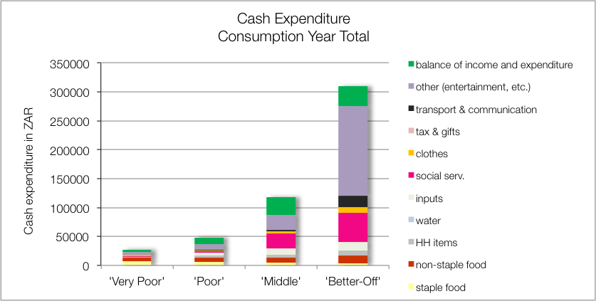

‘Middle’ and ‘better-off’ households try and have their children educated at a tertiary level (university or college) and this places a substantial financial burden on the households. ‘Poor’ and ‘very poor’ households, on the other hand, send their children to free schools and are not able to afford tertiary education.

‘Middle’ and ‘better-off’ households also travel more, with the former using paid public transport and the latter servicing and fueling their own private vehicle.

All households in this livelihood zone are obliged to purchase water, with the ‘middle’ and ‘better-off’ purchasing and spending twice as much. The total cost of water is nevertheless not too significant: about R360 per annum for the poorer households and R720 per annum for the wealthier households.

The balance of income and expenditure can be used for households to invest in livestock, improve their dwellings and may also be invested in cropping if there were incentives. For now, households prefer to concentrate their efforts on seeking paid employment.

Figure 10: Sources of annual cash income as a percentage of total, by wealth group

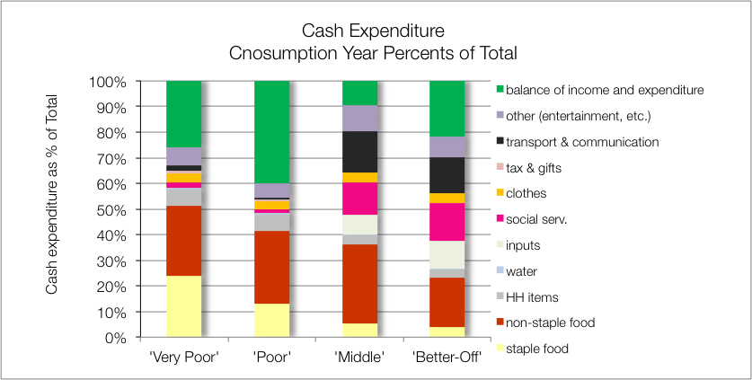

|  |
| --- |
| Hazards, Vulnerabilities and Response Strategies |

The most reported hazards in this zone include drought, intermittent flooding and frost. Since households are dependent on markets for most of their food, households are most vulnerable to market-related shocks. These 'market shocks' may consist of: escalating food prices, eroded grants which might not be adjusted to match consumer inflation) and job losses. Wealthy groups are able to sell their produce and livestock for better prices compared to the other wealth groups.

Drought, frost and wind may have an impact, as it will reduce crop and livestock production and affect this source of food and income. However, unless food prices also rise simultaneously, households will manage crop losses by prioritising more cash to food purchases. Some of the main challenges in the zone also include livestock theft and livestock diseases.

Additional response strategies households may engage in under stress are: switching expenditure, selling off assets and casual labour.

|  |
| --- |
| Household Hunger Score |

The ?? of the households (?? percent) experience no to little hunger and two per cent of households had severe hunger in this livelihood zone. ?? per cent of the households reported a moderate hunger situation – see **Table II**.

Table 2 - Household Hunger scale indicator

|  |  |  |  |  |  |
| --- | --- | --- | --- | --- | --- |
| No to Little Hunger | | Moderate Hunger | | Severe Hunger | |
| Count | Percent | Count | Percent | Count | Percent |
|  |  |  |  |  |  |

Source: Survey Output 2015

|  |
| --- |
| Dietary Diversity and Food Consumption Score |

The largest number, 40 percent of sampled households, have medium dietary diversity scores indicating that they consume four to five food groups during the day before the survey. 29 Percent of households have the highest dietary diversity (at least six food groups) and there are 31 percent of households with the lowest dietary diversity indicating that they consume three or fewer food groups.

Figure 11: Dietary Diversity Scores

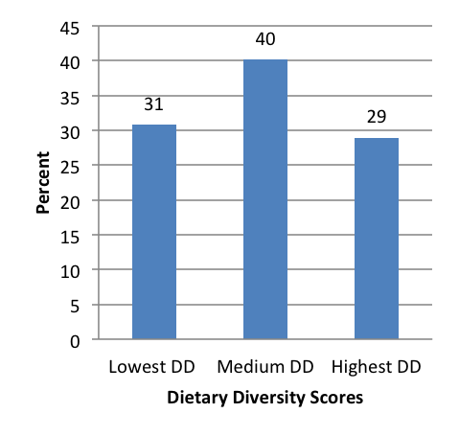

Figure 12: Food consumption scores

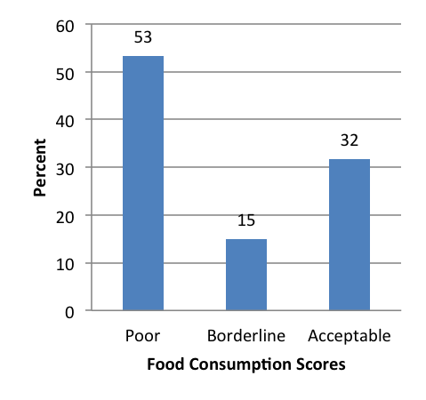

The majority of households – 53 percent – were consuming poor diets. While 20 percent of the households were within an acceptable consumption pattern, 15 percent of the households were within borderline consumption pattern.

|  |
| --- |
| Nutrition and Anthropometry |

Acute malnutrition is predominant in the 36-47 months old children in the livelihood zone (Figure 11). About nine percent and two per cent of under-five children were moderately and severely malnourished, respectively in the livelihood zone. The missing of figures in the other age group categories were not picked up in the sample of the livelihood zone.

Figure 13: Prevalence of severe and moderate acute malnutrition by age grouping

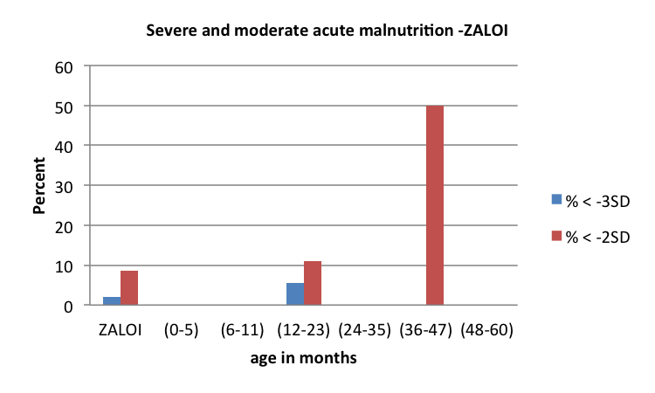

The prevalence of severe and moderate stunting is 27 per cent and 11 per cent, respectively in the livelihood zone (Figure 12). There is a high prevalence of severe and moderate stunting among under-five children within 48 to 60 months of age seconded by children who are 24 to 35 months old. The trend of moderate and severe stunting is increasing as under-five children increase their ages from 12 months to 60 months. The results also indicate that there were no moderately and severely stunted under-five children with 0 months to 11 months in the livelihood zone.

Figure 14: Prevalence of severe and moderate stunting by age grouping

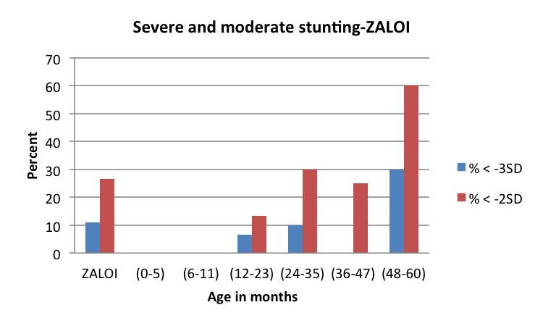

The prevalence of moderate underweight was six per cent in the livelihood zone (Figure 13). There is a high prevalence of moderate underweight (25%) among under-five children within 36 to 47 months of age seconded by children who are within age categories of 24 to 35 months and 24 to 35 months old. The results indicate that there is a zero prevalence of severe underweight in the livelihood zone. The results also indicate that there were no moderately and severely underweight under-five children with 0 months to 23 months in the livelihood zone.

Figure 15: Prevalence of severe and moderate underweight by age grouping

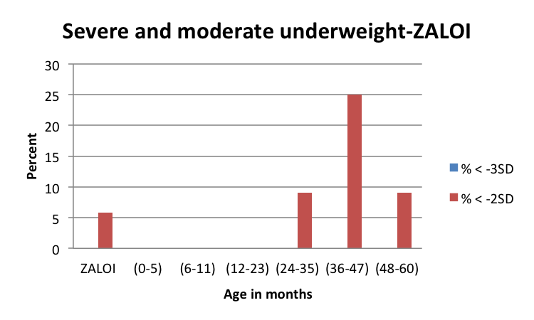

|  |
| --- |
| Conclusions and Recommendations |

As it has been seen that the zone has mixed income sources, key to the development will be to improve the access to government services so that the people have diversified means of income. Agriculture has a huge potential in the zone as there are a number of dams which can provide stable source of water if the irrigation schemes are put in place. Livestock farming could thrive in the areas around Dr JS Moroka Municipality, but will need veld management to control bush encroachment.

Figure 16: Detailed map of the livelihood zone showing the sampled sites, other livelihood zones, administrative areas down to enumeration small areas, and infrastructure

